# Statement of Significance – Major projects

Guidance on completing this form can be found on the ChurchCare website at <http://www.churchcare.co.uk/churches/guidance-advice/statements-of-significance-need>

*This document must be accompanied by the Standard Information Form 1A*

**Section 1: The church in its urban / rural environment.**

**1.1 Setting of the Church**

How does the setting out of the church contribute to its landscape / townscape value and to its significance?

The church's strategic placement within the village enhances its landscape and townscape value, underscoring its historical and cultural significance. As a central focal point, the Gothic structure with its irregular design and iconic square tower creates a visually captivating scene against the natural backdrop. The ancient architecture, featuring North and South porches, reflects a timeless aesthetic, while the various divisions within the church highlight its historical evolution. The churchyard, with its relics and the unique "Kneeling Cross," adds archaeological depth, connecting the present community with its past. In essence, the church's careful positioning, architectural elements, and historical artifacts contribute to its landscape value, making it an integral part of the village's identity and a testament to its rich history.

**1.2 The Living Churchyard**

What is the significance of the natural heritage of the site?

The churchyard holds natural heritage significance through its collection of ancient tombstones, stone coffins, and fragments dating back centuries. This repository of historical artifacts contributes to the site's natural heritage by preserving the remnants of past civilizations. The presence of a weathered altar-tomb and the pedestal of a "Kneeling Cross" reflect the enduring natural qualities of the limestone used in their construction, attesting to the geological heritage of the region. Additionally, the flora and fauna that have established themselves within the churchyard over time become part of the natural heritage, representing the adaptation and resilience of local ecosystems. This intertwining of human history, geology, and biodiversity in the churchyard creates a living tapestry of natural heritage, fostering a connection between the contemporary community and the enduring ecological and geological processes that have shaped the site.

**1.3 Social History**

What is the historic and present use of the church and churchyard by the congregation and wider community? How does this contribute to its significance?

The church and its churchyard have served as integral communal spaces for both the congregation and the wider community, enhancing their historical and present significance. Historically, the church has been a focal point for religious worship, marking significant life events such as baptisms, weddings, and funerals. The churchyard, as a burial ground, preserves the memories of past community members and contributes to the continuity of local heritage.

In the present, the church continues to be a space for religious practices, fostering a sense of spiritual community among its congregation, with contemporary regular worship on Sundays and traditional language on Wednesdays (at which we are often joined by the village school).

Additionally, the church and its surroundings often host community events including the weekly choir practice, a monthly lunch club, concerts, and occasional exhibitions, creating a shared space for cultural activities, celebrations, and gatherings. This dual function of the church and its grounds as a religious and community center underscores its contemporary relevance and strengthens the social fabric of the wider community.

**1.4 The church building in general**

Provide a description of the church.

All Saints' Church in Ripley is a grade II* listed building, and a notable example of medieval architecture, dating back to the 15th century. The exterior features characteristic Gothic elements, including pointed arches and functional buttresses. The square tower, with its externally accessed stairway, is a prominent structure, and contributes to the overall verticality of the design. These architectural choices reflect the skilled craftsmanship of the medieval period.

The interior of the church reveals further architectural details. The nave, characterized by pointed arches and clerestory windows, imparts a sense of spaciousness and illumination. The use of enduring materials underscores the commitment to longevity. Architectural elements such as moldings and tracery showcase the artistry of the medieval craftsmen.

A distinctive feature of All Saints' Church is its painted ceiling, providing a layer of cultural and historical significance. The intricate patterns and depictions on the ceiling serve as a reflection of victorian artistic sensibilities, offering insights into the cultural tapestry of Ripley during that period.

The chancel, distinguished by architectural refinement, provides an intimate space for worship. Carefully designed arches and strategically placed windows contribute to an atmosphere conducive to contemplation and spiritual reflection. The chancel arch, a prominent architectural feature, serves as a symbolic gateway to the sacred space beyond.

In conclusion, All Saints' Church in Ripley stands as a testament to medieval architectural brilliance. Its Gothic design, both externally and internally, reflects the craftsmanship of the era. The church's architectural elements, including the painted ceiling and the chancel, contribute to its historical and cultural significance within the community.

|  |
| --- |
| **1.5 The church building in detail**  The Church consists of six principal divisions or compartments, separated by circular and octagonal pillars and pointed arches, consisting of a nave with two side aisles, a chancel, two ‘chapels’, and a baptistry. The original 14C church consisted of the Nave, Chancel, and vestry; at some point in the 15C a south aisle was added, along with north and south chapels. In the 16C the roof was raised, the tower doubled in height, and the external staircase added (dated in lead 1567). The baptistry was created as part of a Victorian ‘restoration’ in the late 19C.  The west end also houses two later timber insertions serving as a choir vestry on the south side, and a kitchenette/toilet on the north – these late 20C fittings are not considered to be of any particular significance.  The Nave  Until 1862, the nave and chancel were separated by a finely carved oak rood screen, which was supposed to have belonged to the old sanctuary previous to the erection of this Church. As part of the Victorian restoration of 1862 (or possibly later in 1886), it was removed, and placed in the South Chapel (now the organ); and its venerable appearance renders it an object of great interest to the antiquary, though the violence done to it in reducing it to relocate is a great shame. Its original extent appears to have been much greater than at present. As its Saxon name indicates, it has most probably been surmounted by a crucifix near the altar in the old sanctuary, separating the nave and chancel. It seems from an old MS. in the Castle, that "originally there were twenty coats of arms painted on shields or labels along the top, mostly of the Kings of Europe, and some of the Ingilby family. The eighteenth shield bore the inscription :REX IOHS; and the letters similar to those extant on coins of King John's time. These letters were visible, though partly defaced, in 1763. It is supposed that this screen was first erected about A.D. 1200," though it was said 1040 was discovered on some part of it. This must be considered an item of high significance.  After the Reformation, the interior was fitted up with large square oak pews, with pulpit and reading-desks of the same material, placed in the centre of the nave-all of which remained till the restoration, when they were replaced by open seats of pitch pine with stall ends, standing on a continuous wooden floor. The design is plain, and the execution adequate.  When the old pews were removed, in 1862, a niche was discovered at the Eastern end of the South aisle. It is assumed that this is a pre-reformation (15C) piscina. This is an item of ancient and historic interest, and considered to be of high significance.  The South door is thought to be of 14C workmanship, with a particularly fine outer face of riven oak boards, and decorative iron hinges. It may have been brought to the current church from the previous ‘Sinking Chapel’. Considered to be of high significance.  In the South aisle of the nave are four stained glass windows of two lights each. The first was presented by Mrs. Lloyd, of Killinghall, and is of geometrical design. In the lights, within medallions, are figures of St. Matthew and St. Mark. The inscription at the foot is-" In memory of Albert, Prince Consort; born 1819, died 1861. Blessed are the pure in heart, for they shall see God." This window is by Mr. Ballantine, of Edinburgh. The next in order contains representations of the presentation of Christ, and the Saviour weeping at the tomb of Lazarus. The inscription at its base is "In memory of William Strother, who died 18th June, 1839, aged 66 years; also of John Strother, M.D., Ellen Ragg, Mary Wade, and Ann Strother, his son and daughters." The third represents Christ bearing His cross, and Christ blessing little children, with the inscription-"In memory of Richard Strother, who died the 24th of February, 1854, aged 71 years; and in memory of Richard, Louisa, Ann, Richard Morris, and Thomas Arthur, children of Thomas and Eleanor Strother." These two windows are by Messrs. Warrington and Sons. The fourth window is of geometrical design, with figures of St. Luke and St. John in the centre of the lights; executed by Mr. Ballantine. It is erected in memory of Richard Pawson, and of Jane and Ann his daughters, dated 1862. Representing a variety of styles, and each undertaken well they are considered to be of high significance.  (It is believed that there was previously another stained glass window at the Western end of the aisle At the Western end of this aisle is one of geometrical design, with the following inscription" Presented by Quintin Acomb, in affectionate remembrance of John Acomb, of Knaresbrough, who died 31st August, 1855." By Chance, of Birmingham; with a corresponding window at the end of the North aisle by Mr. Knowles, of York. In one light it represented Christ as the Good Shepherd, and in the other Christ standing at the door to knock. At its base was the inscription "In memory of Eleanor Fletcher, who died in Christian peace, A.D. 1859. It is possible to discern in the plasterwork of the wall where the missing window likely was, but its final resting place is unknown. A similar marking can be discerned in the plasterwork on the facing southern wall, implying there was also once a window there; it is presumed that these may have been taken out to allow the addition of the porches to the church?)  The nave floor contains a number of interesting grave slabs, though it is unlikely any are where they originally were, as during the ‘restoration’ it was considered necessary to remove the floor, and few stones were replaced in their original locations. Of particular note in the nave are a 14C Priest’s grave slab, thought to have been brought from the sinking chapel with the exhumed remains of the priest; and a large black mable slab thought to be the tomb of Sir Thomas Ingilby (d. 1415), the founder of the church.  The tomb of Sir Thomas Ingilby (d. 1369) and his wife Lady Edeline is also in the nave, being a 14C effigy chest tomb. Like other 14C pieces it was brought up from the Sinking Chapel. A late 19C description mentions the presence of a child lying between them, but this is no longer apparent if it ever were. For their historical interest all the graves and tombs are considered of medium to high significance.  Near the entrance to the ‘Ingilby Chapel’ can be found a piece of carved stone, presumed to be a medieval gravestone, inscribed with a laver one face, and cross on the reverse. It is hard to guage the significance of this piece as not enough is known about it.  The Chancel  Similar to the nave, the Chancel contains a number of grave slabs, all presumed moved by the Victorian ‘restoration’ to their current locations. Of particular note is a 15C priest’s grave slave beneath the bishop’s chair next to the vestry door. It is a memorial to Ricardus Kendale, d.1421, the last Recto of the Sinking Chapel, and the first of the current church. Spanning this moment in time, it must be considered of high significance. Increasing the significace is the belief that it may be the earliest representation in the country of a chalice in a monumental brass.  The tomb of Sir William Inbilbie (sic), d.1617, is against the south wall of the chancel. A large and ornate piece, with an interesting inscription, playing on the phrase ‘a single bee’ for the name ‘Ingilbie’. High significance.  Behind this tomb can be seen two earlier 15C features. The first a priest’s Sedilia, which sits adjacent to a diagonal cut in the wall through to the vestry. Known variously as a ‘Hagioscope’ or a’Squint’ the precise function of this feature is not now known. It may have been to allow a view of the elevation of the host during mass, or for the ringing of a Sanctus Bell, or to allow for confession to be conducted through the wall. Medium to high significance.  Further along the same wall is an anicent Piscina and Credence Shelf carved from stone, believed to have been brough up from the Sinking Chapel. Antiquity and ties with the previous church suggest high significance.  The Chancel contains a number of Stained Glass Windows. The East Window, with its three fine lights and ornamental headings, was restored by Lady Amcotts Ingilby, in memory of her husband, Sir William Amcotts Ingilby, and bears an inscription to that effect on a brass plate at the foot of the window, dated 1862. It has undergone more recent restoration wor to bring it back to good repair in 2021. In the tracery within a sexafoil is a figure of our blessed Lord in glory, supported on each side by an angel, with the words-"I am the Resurrection and the Life." The first light is a representation of the Nativity. Above are two angels supporting the text-" Glory to God in the highest, and on earth peace, good will towards men." Below is the motto-" Unto you is born a Saviour." The centre light illustrates the Crucifixion, with "Inri" above the Redeemer, and beneath the inscription-"Jesus Saviour of Men." The representation of the Resurrection forms the subject of the third light, with the words-" The Lord is risen indeed." This window is by Messrs. Ward and Hughes, of London. The next, on the North side of the Chancel, a two lighted one, the work of Messrs. Clayton and Bell, of London, is, in both compartments, illustrative of the ResurOne pourtrays the incident of Christ saying to Mary-" Touch me not, for I am not yet ascended;" and the other His remark to St. Thomas-"Reach forth thine hand, be not faithless but believe." At the foot of the window are the inscriptions" In memory of Rear-Admiral Sir R. Barrie, K.C.B. and K.C.H., born 1774, died 1841; buried in this Church;" and "In memory of Julia Wharton Barrie, wife of the former, and daughter of Sir John Ingilby, Baronet, born 1794, died 1836. On the opposite side of the Chancel is another corresponding window by Wailes and Son, of Newcastle. Two beautiful figures of Faith and Hope are placed in this window. The canopies above are of artistic design and rich in colour. Below Faith is the text-"Looking unto Jesus, the author and finisher of our Faith ;" and beneath Hope is the passage-" Which hope we have as an anchor of the soul, sure and steadfast." On a brass plate beneath is engraved—“ In affectionate remembrance of John Williamson, of Hollins, born 1808, died 1854. This window is erected by his widow and two sons  All considered to be of high significance as individual pieces of well executed artwork.  The chancel ceiling features colourful stencilled artwork, believed Victorian. Of particular interest in it are the deliberate mistake, and the change in style and colour in the ceiling above the sanctuary which contains two panels depicing the lamb of God and the less common medieval motif of a pelican feeding her young. Unusual but not unique, therefore considered to be of medium to high significance.  The ‘Ingilby Chapel’  The date of this section of the church is not known, though recognised as a chantry chapel it must predate 1547.  The 1862 works installed the current pews for the Ingilby family.  This part of the church contains very memorialst to members of the Ingilby family (considered of high significance for their historical interest, and in some cases workmanship), as well as the entrance to the 18C family crypt – now covered over and rendered inaccessible by the Victorian pews.  The chapel is adorned with a two-light window, both of which represent our Saviour's charge to St. Peter to "Feed my Lambs." The canopy is rich both in design and colour. This window, which is by Messrs. Warrington and Sons, of London, has the following motto at its base-"In memory of Mary and Catherine Ingilby, founders of the Ripley School, 1702. By old scholars, 1862." High significance.  Organ ‘Chapel’  Occupying a space on the South side of the Chancel, the organ almost fills what was once a second chapel. The organ compirses two complete manual and pedal board cc – c.61 notes and ccc – F. 30 notes. The console which is en fenetre is contained within the organ case. The pedal board has a central swell pedal and three pistons on either side. The organ is electric or tubular pneumatic action and much small bore lead tubing is visible in the organ case within the upper board The pipes are 70% tin with lead. The maker’s name Abbott & Smith in black letterng is on a small white plate above the swell manual. The organ has not been altered since 1938. Medium to high significance.  In the wall behind the organ casement is a fine window of geometrical pattern, containing three lights. In the centre is a teacher dictating to his pupils, with the text-"Happy is the man who findeth wisdom." This window is by Messrs. Warrington, and is in memory of Mr William Cockett, who for 45 years was the zealous and respected master of Burnt Yates School, erected by a number of his old pupils. The fact is recorded at the foot of the window. As a piece of local history, and decent craftsmanship this is considered of high significance.  Baptistry  The font dates from 1846 and is carved in Caen Stone. It is a memoral to Quintin Acomb. Moved to its present location from the South West corner of the church in 1886. Low to medium significance. |

|  |
| --- |
| **1.6 Contents of the Church**  Provide a description of its contents and their significance. It is reasonable to group these if there is a contemporary scheme which is significant as such, for example one could say a complete scheme of 18th-century furnishings, of high significance.  The majority of the furnishings date from the late 19C, corresponding to the Victorian restoration of the building. Low to medium significance.  The freestanding pulpit is possibly of higher significance, comprising an intricate cast iron frame, combined with wood. ‘Very unusual to have a combined metal and wood pulpit’, therefore medium to high significance.  All Textiles 20C, poor to satisfactory condition. Not believed to be of any particular significance.  Seven funerary Hatchments 18-19C. Well constructed, and of historical significance.  Three 17C Ingibly Pennants, high significance.  Standards of British Legion Killinghall and District Branch; Scots Guard Association, Durham and Yorkshire Branch; Ripley Girl Guides (along with their Union Flag); Ripley Chhurch. Low to medium significance variously.  Benefaction Boards, 19C, local historical significance. |

**1.7 Significance for mission**

What are the strengths of the building as it is for worship and mission? What potential for adapted and new uses does the church and its setting already have with little or no change?

The buildings greatest strength is the the sense of connection to the deep past, and the grandeur it inherits from its medieval roots. The open space presumed of the earliest form of the church would have offered great potential for various uses, but the fixed nature of the current space, and the limited space for movement and activity severely limits its current potential. There is scope to increase the profile of the site as of historic interest, drawing out many of the stories inherent in its fabric, but that does not offer any new use. There is very little that could be done with little or no change.

**Section 2 : The significance of the area affected by the proposal.**

**2.1 Identify the parts of the church and/or churchyard which will be directly or indirectly affected by your proposal.**

The wooden furnishings of the chancel, nave, and ‘Ingilby Chapel’ will be affected by the current proposal to varying degrees; the nave significantly, the Ingilby Chapel slightly, and the chancel negligibly.

**2.2 Set out the significance of these particular parts.**

The Choir Pews

Descrription

Baltic oak; 1886 (Faculty RD/AF2/9 Ripon Diocesan Records West Yorkshire Archives, Leeds); South and North identical

Rear stalls are standing on redwood blocks laid in herringbone pattem to raise them from the stonefloor, front stalls on oak parquet

REAR STALL

h.104cm x 1.252cm x w.22cm - ann 48cm

Plank construction; back-tongued and grooved with plain squared top rail and slab seat. Arm rests with 2 rolls over covette moulding and curved sweep to elbow. The bench seat has three supports below.

CLERGY STALL

h. 104cm x 1.71 cm x w.22cm

Single seat has two arm rests.

FRONT STALL

h.65cm x 1.250cm x w. 14cm

Bench seat; slab ends with chamfered curved elbow and two curved supports below. The back has four plain panels surmounted by four carved and pierced panels - a roundel with central rose in pierced quatrefoil, and on either side two cusped mouchettes. An overhanging frieze carries a flat bookrest for the seat behind; below that is a shelf with chamfered beading forming a container for books.

SINGLE SEAT

h.65cm x 1.250cm x w.14cm

As Front Stall, with two ann rests

BENCH FRONT WITH BOOK REST

Flat top carried by five shaped supports chamfered behind and reeded in front with an ogee frieze in

each bay; it rests on a solid base chamfered in front with projecting stools for the five supports. A

stretcher with cavetto, surmounted by an ovolo across the base in front, and a rail behind forming

container for books.

Carved panel h.13cm x w.49cm; Platform h.14cm

Significance

The choir stalls are good examples of Victorian woodcarving and construction. They offer no particular unique features that are uncommon or of substantial significance. In any case they will be retained entire through the proposed works.

The Ingilby Chapel Stalls – Oak, 1862

Description

Base - w.237cm x 1.498cm

REAR STALLS

Rear seats h. 122cm x w.64cm x d.41cm x h.of seat 44cm

Seven separate conjoined winged seats with framed panelled back and scrolled arm rests reaching the floor. Each slab seat has a 3cm extension in front. A continuous flat chamfered top rail connects all seats projecting over wings with expanded circular end with roll moulding. A door of four planks with a roll top, seat high, encloses the East end.

FRONT SEATING

Front seat h.99cm x 1.487cm x d.4()cm x h. of seat 44cm

A continuous solid bench seat supported by slab bench ends and four intermediate supports. Rounded corner projects in front of slab ends. This is rectangular with a projecting elbow and surmounted by a carved fleur-de-lys poppy-head over a reeded collar. Below is a blind quatrefoil in a roundel on a punched ground. The back is of five framed panels above, and vertical tongued and grooved boards below seats. Behind, a top rail carries a sloping bookrest with rounded beaded edge to retain books. Below seat at West end a small drawer with button handle and baize lined compartments

BENCH FRONT

Bench end h. to top of fleur-de-lys 150cm; h. of shelf Illcm x w.26cm x 1.487cm

A chamfered top rail connects five bays separated by chamfered uprights. Each bay has four trefoil

headed arches with pierced spandrels and at the base a carved quatrefoil in a roundel. The bottom rail is chamfered. The top rail carries a sloping bookrest with a rounded top and a ledge at the bottom. Below this at the West end is a flat shelf and a very small cupboard to hold one small prayer/hymn book. (Madc specifically for The Hon Lady Alberta Ingilby (ref a) by J. Boucher, Ripley Castle.) The slab ends are as in front seating, without the elbow and seat support. All four poppy-heads (made and carved by the Castle carpenter (Orally - Diana, Lady Ingilby, Ripley Castle)) are different. Bench front and all lines of seating are raised from the floor on a wooden platform covered by coconut matting. All seats have cushions.

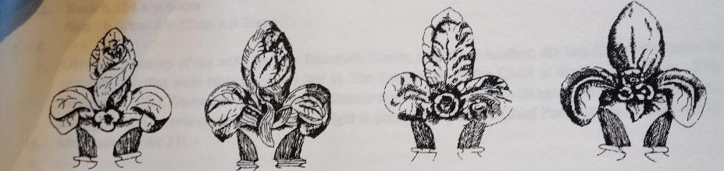

Significance

Similar to the choir stalls, the Ingibly Stalls represent good examples of Victorian carving. The four unique poppyheads may be considered of some significance being individual works of art, rather than standard designs. With the front rail being retained, only two are at risk, and it may be they could be detached from the pew proposed for removal, and integrated in a similar position to the rear stalls, thus retaining the art within the church.

The Nave Benches

Description

Oak and Pitch Pine, Arranged as plan

1862, East of passage; 1886 West of passage; conversion of back bench to cupboard 1968

h.94cm x l.(nave) l. (aisle 230 x d (of seat) 33cm

Footrest 2.5cm x 2.5cm; Book-ledge w.12cm; Box 1.40cm x w.20cm x d. 19cm

BENCHES - constructed of mixed woods, and all standing on a continuous wooden floor (cross ref 806). Slab BENCH ENDS have chamfered rectangular tops and curved elbow on rectangular chamfered plinth. The tops have a carved blind quatrefoil on a punched ground on the aisle faces except the South back bench which is plain. The BENCH SEATS rest on one or two angled supports, have rounded corners projecting in front of the slab ends and a dividing elbow in line with the stone pillars. The panelled backs are surmounted by a rail and a roll moulding; on the rear face a smaller chamfered rail and second rolled moulding, and below a flat book ledge. Below the seat are boarded backward sloping panels, except in benches behind the passage from North to South doors. Near the base a single rail FOOTREST for use of the seat behind. In front of all front pews is a BENCH FRONT of tongued and grooved planks in a frame sunnounted by a rail and bookrest as above. The end SUPPORTS are oak posts with a quatrefoil in mundel on a punched ground, except on the North side, West of the N/S passage which is blank.

Pews to the East of the passage have painted numbers on the ends of the book rest - but some missing and not necessarily consecutive. Mr Homsey's family paid to sit in pew 24; Mr and Mrs Hodgson in pew 38; Mrs Hodgson kept her bible and prayer book in her attached box (Orally - Mr D.M. Homsey, 32 Manor Gardens, Killinghall)

Significance

The nave pews are solid, but pedestrian. Such particular design as there is is limited, and not unusual.

**Section 3: Assessment of the impact of the proposals**

**3.1 Describe and assess the impact of your proposal on these parts, and on the whole.**

The impact on the choir pews will be negligible; the increased height of the front pews may change the appearance slightly, but in no way detrimentally.

The impact on the Ingilby pews is more significant, with the removal of one of them impacting something that was created as a single scheme; however the work will be undertaken to ensure that a cohesive whole remains, and the impact on the chapel as a whole will be to significantly improve its amenity, allowing more space to explore the funerary monuments and materials, and creating the potential to reopen the Ingilby vault should that ever be necessary or of sufficient historical interest. It is also worth noting that, as with the nave, the original historic medieval fabric is not being intruded upon, but rather more fully revealed.

The impact on the nave will be significant, with the removal of the pews. With well-chosen chairs, however, the visual impact will be minimised, and the overall impact on the sense space should not be overly affected as it relies more heavily on the medieval architecture than it does on the relatively recent wooden pews. With the generation of greater flexibility in the space it may also make it easier to draw attention to, and encourage exploration of, the articles of higher significance in the building.

The impact in terms of usability of the spaces throughout, both for community and liturgical purposes will be significant, enhancing both tremendously. There is no planned impact on the liturgical tradition of the church, but with flexibility of arrangement it will be possible to create more welcoming, inclusive, and integrated arrangements encouraging worshippers and visitors to engage more fully with the building, as well as their activities.

For clarity there is no impact to the stone areas of the floor, including the grave slabs/ledger stones all these areas will remain undisturbed and as is.

**3.2 Explain how you intend, where possible, to mitigate the impact of the proposed works on the significance of the parts affected and the whole.**

* We will factor in the overall appearance to the choice of chairs to replace the pews to stay so far as possible within the spirit of the space.
* Examples of the pews will continue to be present in the church in the wall seating currently in place at the west end of the church, which is not impacted by these proposals. The two ‘L-shaped’ pews in the current proposed design drawings are existing furnishings and not a new feature.
* One pew contains a small brass plaque in memory of Dr. James Fison. We would be looking to relocate this plaque within the church rather than remove it entirely.
* The sinking of the current pew platform to the level of floor will ensure the legibility of the change, and retain a good amount of Victorian wood in the building.

**Sources consulted**

‘A short history of All Saints’ Church, Ripley’ by Ted Bishop, self published.

‘Ripley: its histories and antiquities’, John Thorpe, 1866

NADFAS Report on All Saints’ Church

**Statement of Needs – Major projects**

Guidance on completing this form can be found on the ChurchCare website at <http://www.churchcare.co.uk/churches/guidance-advice/statements-of-significance-need>

*This document must be accompanied by the Standard Information Form 1A*

**1. General information**

This should provide an overview of the parish and the current use of the building.

All Saints’ Church is currently used for regular worship on Sundays and Wednesdays. The worship style varies from contemporary Common Worship (Sundays), supported by a growing and active choir, to Traditional Language (Wednesdays). Sundays average an attendance of around 50, and Wednesdays around 15. Our least formal intergenerational services commonly involve the opportunity for ‘breakout’ activities, and the free movement of the congregation between those activities that interest them.

At certain festivals we celebrate in particular ways, for example our Passion Play on Palm Sunday, which begins in the village, and makes its way into the Church, using the space at the front and the back; or our Christmas Eve Crib Service involving local children and animals in dramatic retelling of the Christmas sotry.

The Choir rehearse in the Church on a weekly basis.

Throughout the Summer a weekly volunteer cafe is hosted in the church on Thursdays, and some Bank Holiday Weekends. It is well attended by many visitors to the village.

Throughout the year we host up to six concerts of varying musical styles, we have hsoted individual acoustic artists, and full choirs.

We have hosted an annual market-style ‘Christmas Fair’, with local artists and traders hiring table space, as well as occasional other seasonal fairs of similar style.

The space has been used for exhibition days e.g. for Holocaust Memorial Day, or an Climate Awareness Day, or School Activity Days, in which various interactive displays and information have been there for the public to explore and engage with. This has at times been done in partnership with outside agencies such as The Wildlife Trust.

The church hosts a monthly Lunch Club, which provides a social opportunity and decent food for an affordable price. Popular with pensioners.

Throughout the day the church is open for visitors to explore, and a large number of tourists pass through. They are engaged directly through our candle tray, occasional prayer installations, a tree of thanks, and a ‘little pig exploration trail’ for children (knitted pigs around the church explaining their role in the church community e.g. choir member, bell ringer etc.)

The church hosts around 10-20 weddings a year, a resultinly similar number of baptisms, and slightly fewer funerals.

**Ingilby Pews**

The ‘Ingibily Chapel’ is very rarely used as seating for services, and is unsuited for anything else. There is a lot of history in this space and creating greater space here would allow for it to be more easily and comfortably explored, increasing our capacity to engage with tourism and build connections with the wider community. Having a larger floorspace available also increases the flexibility on how this space can be used e.g. breakout space during worship, quiet space for prayer during cafe days, location of temporary prayer installations or exhibits, vestry space for visiting (or local) choir etc. Increasing the usability of this space, and therefore its use, would also discourage the bad practice of using it as a ‘dumping ground’ for quick and easy storage of items not needed ‘right now’.

**Choir Stalls**

From the heights of the front stalls, it is evident they were originally designed to seat children. They are significantly lower than the rear stalls, and very close to the bench front. The height, and lack of leg room make them both difficult and uncomfortable to sit in for adults. Additionally, the lower height of the front stalls lowers the height of the bookrests for the rear stalls, reducing their comfort and efficacy. This is an increasing issue with the size and weight of the modern music hymnbooks in regular use in our church.

For some years our choir, which continues to be strong in membership, has been comprised of primarily adults. There are more members than can fit on the rear pews and we need to be able to seat them comfortably and easily on the front row as well as increasing the amenity of the rear row to continue to encourage the growth and membership of a flourishing rural church choir.

Additionally the Chancel is regularly used for our Wednesday morning traditional language communion, which has been growing in recent years up to a regular congregation of 15-20. We hope to see this growth continuing into the future. Using the Chancel provides a worship space suitable to the size of the congregation, which would feel ‘lost’ in the larger nave. The discomfort of the front pews impedes the seating capacity of this area of the church, and thus the growth potential of this service.

**Nave Pews**

The existing pew configuration poses specific limitations that impede the congregation's growth and hinder the versatile use of our sacred space for various activities.

The primary challenge posed by the current pew setup is the restriction of available space for activities and the hindrance to smooth congregational movement within the building. This is particularly evident during the least formal communion service held on the first Sunday of each month at All Saints'. The deployment of a portable nave altar and movable AV screens, supported by our worship group, is impeded by the current pew arrangement. The confined space and a single central aisle create difficulty for congregants to approach the front comfortably, thereby impeding their participation in the eucharistic components of the service. The implications of this limitation extend to our regular intergenerational services, where activities for 'liquid worship' are constrained by the small, closely packed spaces dictated by the pew configuration.

This challenge further impacts the variety and styles of worship desired by our growing congregation, currently averaging around 50 attendees weekly. For instance, in the past we have held well-received and popular cafe-style services, but accommodating more than 30-40 congregants comfortably becomes a logistical hurdle meaning these are no longer an option for us. Other ideas to complement more traditional worship, such as worship gathered around a central altar also are impossible with the current setup.

Our activities outside of worship, such as our weekly summer café and Christmas and Craft fairs also face challenges due to the pews. Cafe seating around tables is severely restricted to the spaces left around the edges of the pews, which at busy times means people are left with very little space**. [SEE PHOTOS AT THE END OF THIS DOCUMENT].** Additionally using the available space restricts the possibility of leaving some areas available for quiet personal prayer – particularly apparent when a table has to be set up next to our permanent candle-lighting station, infringing on its space, privacy, and therefore usability.

During our Christmas/Craft fairs, as the only available space, the existing pews are repurposed for stalls, but this limits the number available to a mere 8-10. The movement of attendees through the aisles is severely impeded, especially along the side aisles where individuals cannot pass each other comfortably. This severe restriction in movement severely limits access to stalls for browsing and purchasing, diminishing the quality of the experience for both stall holders and attendees alike.

During the concerts we host the potential layouts, and space for performing groups such as choirs, are limited by the inflexibility of the space. For attendees sightlines can be restricted, either by pillars, or by being so forced into straight lines one directly behind another. The pews are also not particularly comfortable to sit on for the length of a two half concert.

**2. What do you need?**

All Saints' Church requires adaptable seating arrangements in the nave to accommodate diverse worship styles and community events, as well as to improve our capacity to engage with tourists and visitors. Flexibility is particularly important for our intergenerational services and now well-established special events like the Passion Play and Christmas Eve Crib Service.

We need the Ingilby Chapel to be be more accessible as a usable space, both for regulated activities, but also to enable visitors to better engage with the history present in the building.

We need the choir stalls to be sufficiently sized to comfortable seat adults throughout to accommodate a growing choir, and Wendesday morning service.

**3. The proposals**

Set out what you are proposing to do in order to meet the needs set out in section 2

* Nave pews to be carefully removed for sale by the church to help fund the project.
* Existing pew platform to be lowered to match the nave floor level and existing timber floorboards to be reinstated. All fixed rows of pews (9 forward facing, one rear facing) to be removed, along with one free-standing pew; replaced by 140 chairs, of which 18 will be styled with arms.
  + The chairs have been chosen in line with current CBC guidance and are not upholstered.
  + The number 140 is a reduction on the current seating capacity, but chosen to give greater flexibility in space. Rarely do we need seating capacity higher than this, and when we do it is already a case of standing room only, and if necessary we would look into temporary hire of additional seating for individual events. If it becomes apparent that more ‘permanent’ seats are required, they may be added at a later date.
  + There is no perceived need to include a chair store in this proposal, as the vast majority of the time the chairs will be in situ in the nave, and if there is a need to clear away some or all for a particular event, they can be stored neatly and safely in the extra space created in the Ingilby Chapel under these proposals.
* Ingilby Chapel central pew to be removed and sold, and the reading pew to be relocated closer to the rear pews, and the platform reduced accordingly.
* Front choir pews to be removed and replaced atop inserted piece to increase their seat height to match that of the rear pews.
* Front reading bench to be moved forward to allow for longer legs.

**4. Why do you need it and why do you need it now?**

Justify your proposals by explaining why you can’t meet your needs without making changes. Also include anything which may have prompted the proposals.

During all services flexible seating would allow us to expand or restrict the number of available seats to scale with expected congregations, enabling us to better foster a feeling of a ‘full’ church, which in turn increases engagement, confidence, and growth. Importantly, the experiences gained during the COVID-19 pandemic underscored for us the necessity of flexible seating. Moveable chairs would have allowed us to more efficiently accommodate social distancing measures, ensuring the safety and well-being of our congregation while enabling us to serve more worshippers during challenging circumstances. Implementing this change now better places us to respond to similar circumstances in the future.

The transition to moveable seating would offer further benefits, specifically tailored to diversify our cultural and community events. Concerts, for example, of which we host up to 6 a year, could be more precisely accommodated, allowing for larger choirs and expanding the variety of acts we could host. The space could be allocated more strategically for performances, accommodating a broader range of performers and performances. Innovative event formats, such as hosting concerts or plays 'in the round,' become viable, providing unique and immersive experiences. The church could also explore hosting events like formal dinners, akin to those hosted by Ripon Cathedral, broadening the repertoire of events we could organize and further engaging our community.

A transition to chairs would offer flexibility, ensuring a more enjoyable experience for both attendees and organizers.

It's crucial to emphasize the vital role events hosted at All Saints' Church play in fundraising for the maintenance of this historic building. The current constraints not only impact event quality but also hinder our ability to generate necessary financial support to preserve the cultural and historical significance of our church.

The envisioned transition from pews to chairs holds the promise of a more dynamic and versatile sacred space. Quantifiable improvements are expected. For example, during events like Christmas and Craft fairs, flexible seating would allow a significant increase in the number of stalls, creating a more vibrant marketplace atmosphere and improving the overall fair experience. In the context of the weekly summer café, adaptable seating would facilitate a more efficient arrangement, enhancing the overall atmosphere of the event. In our worsihp life we would gain capacity both in styles of worship we could offer, and in terms of the number of people who could attend or partake in them.

In conclusion, the replacement of pews with chairs at All Saints' Church, Ripley, is a transformative step toward a more vibrant, adaptable, and inclusive worship and community space, better able to support itself, and engage with its congregation and community into the future.

**5. What is the evidence for the need?**

Please explain who has been consulted.

* Ongoing feedback from regular users of the space, and observation of the limitations has been the dominant factor.
* Discussions have been undertaken with the PCC, as well as our architects.
* A previous scheme has developed into this simpler one following public consultation during an open meeting (*7th April 2019*).
* Conversation has been had with members of the Ingilby family, who have a particular interest.
* Two site visits by the DAC, including Historic England have taken place (27th October 2016 and 5th September 2019).
* Public presentation and meeting took place in the Parish 27th February 2024.

Consultation with the following statutory consultees has taken place relevant to the 2024 proposal:

* Historic England (did not respond with comments on 42 day consultation period)
* HPAB (formerly AMS; responded to confirm they had no adverse comments but offered helpful comments to strengthen supporting information)
* SPAB (declined the invitation to comment)
* Victorian Society (did not respond within the 42 day consultation period)

**6. How is the proposal contributing to the need for environmental**

**sustainability?**

There is no direct environmental contribution. However the removal and reinstallation of the wooden pew platforms in the nave will enable us to more closely examine the possibility of installing underfloor heating at some point in the future. The benefits of this, if sourced from air source heat pumps, has been identified in an RCEF report undertaken on the building. The immediate cost, however, makes those amendments unviable for the moment, but they will be reviewed as an when the current heating system comes to end of life. At that point the information gathered during these works will put us in a much stronger position to judge the feasibility and benefits of making that more substantial change.

The installation of pipeworks etc. is not being considered at this moment in preparation due the increased cost and complication of changing materials, and the decreased reversibility of such a scheme compared to the current one.

**7. What other options to meet the need were considered, taking Point 6 and the impact identified in the Statement of Significance into account?**

More intrusive changes had been previously considered, but these have been scaled back for the moment in the hope that these less disruptive works may be sufficient to meet the needs identified for the current moment, and provide a springboard to potentially greater fundraising possibilities to enable the revinvestigation of some of the other plans at a future date if needed.

The previous plans included extending the chancel step out into the nave to create a dais as a focus for worship. More recently, however, we have come to believe that a fixed intrusion would work against the flexibility that we are trying to create and a more open space in the area would better suit our uses particularly around concerts, and also liturgically on some occasions (e.g. allowing more easily for services in the round, or more dramatic sevices such as Christmas Eve or Passion Sunday).

Consideration was also given to altering the enclosures at the back of the church, moving the kitchenette to the current choir vestry, and using the additional space to add in another one or two toilets. To compensate for the loss of the choir vestry/storage the plan included adding a first floor suspended meeting room above the current choir vestry, out into the body of church over the North side door. The plan also included adding in a staircse and disabled lift to this suspended meeting room.

It may be that some of these alterations may still be looked at again in the future, though some of the vesting needs may be met by the additional space in the Inilby Chapel area. For the moment, however, we feel the better place for attention is developing the usable we have to its maximum capacity, before revisiting whether additional space need be created.

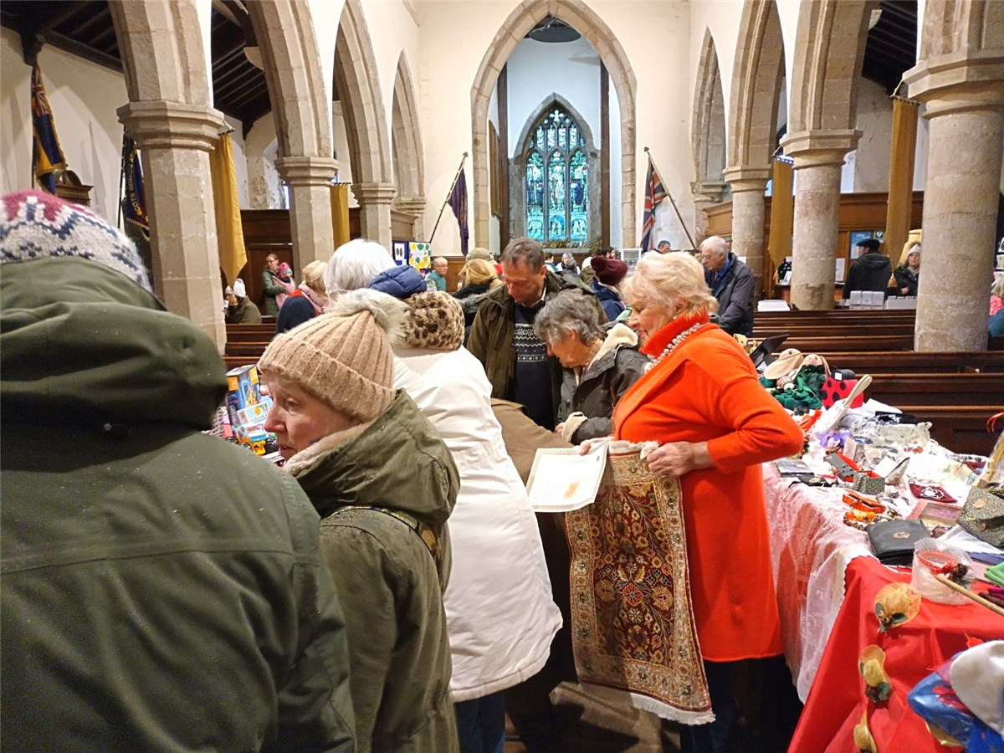

Figure . Nave interior during a festival/event (1)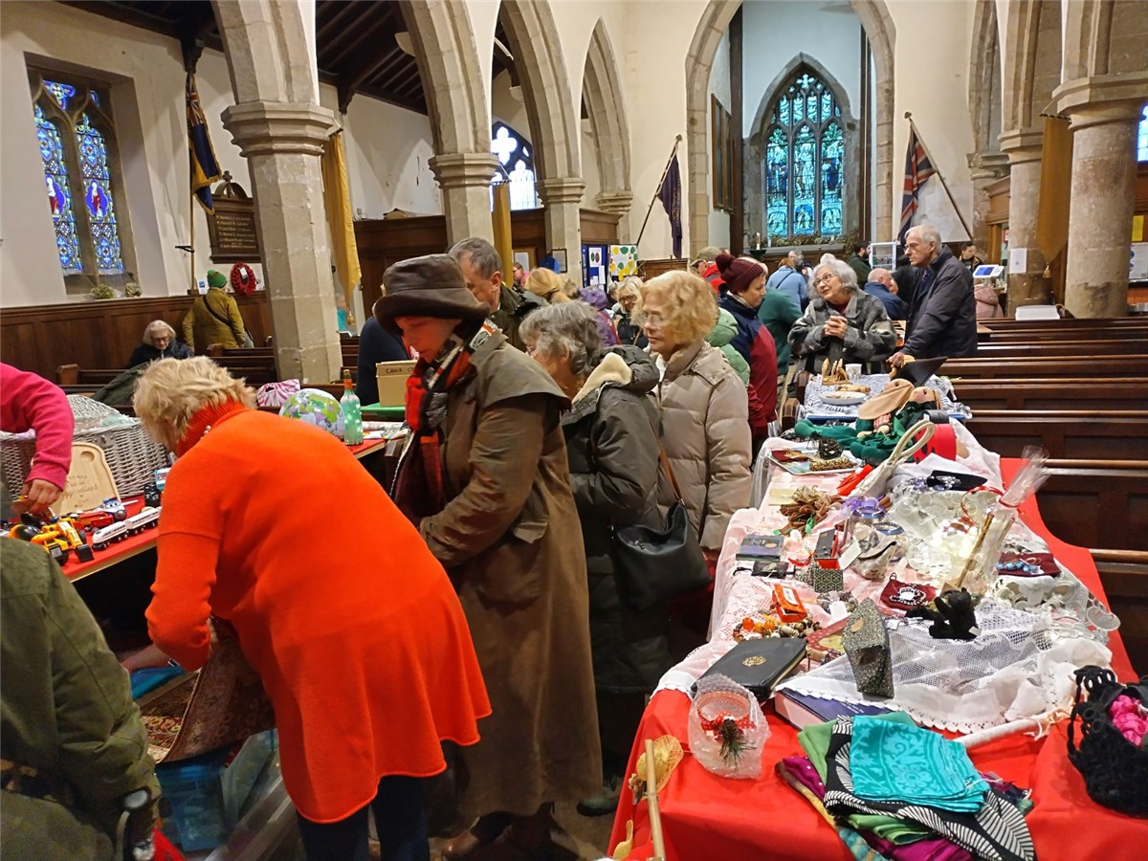

Figure . Nave interior during a festival/event (2)